**Online Crime Reporting**

*Mini Project Report*

*Submitted by*

**Sudeesh E S**

**Reg. No.: AJC22MCA-2092**

*In Partial Fulfillment for the Award of the Degree of*

**MASTER OF COMPUTER APPLICATIONS**

**(MCA TWO YEAR)**

**APJ ABDUL KALAM TECHNOLOGICAL UNIVERSITY**



**AMAL JYOTHI COLLEGE OF ENGINEERING**

**KANJIRAPPALLY**

[Affiliated to APJ Abdul Kalam Technological University, Kerala. Approved by AICTE, Accredited by NAAC. Koovappally, Kanjirappally, Kottayam, Kerala – 686518]

# 2023-2024

## DEPARTMENT OF COMPUTER APPLICATIONS

### AMAL JYOTHI COLLEGE OF ENGINEERING

**KANJIRAPPALLY**



**CERTIFICATE**

This is to certify that the Project report, “**ONLINE CRIME REPORTING”** is the bona fide work of **SUDEESH E S (Regno: AJC22MCA-2092)** in partial fulfillment of the requirements for the award of the Degree of Master of Computer Applications under APJ Abdul Kalam Technological University during the year 2023-24.

**Ms. Nimmy Francis Ms. Meera Rose Mathew**

**Internal Guide Coordinator**

**Rev. Fr. Dr. Rubin Thottupurathu Jose**

**Head of the Department**

**DECLARATION**

I hereby declare that the project report **“ONLINE CRIME REPORTING”** is a bona fide work done at Amal Jyothi College of Engineering, towards the partial fulfilment of the requirements for the award of the Degree of Master of Computer Applications (MCA) from APJ Abdul Kalam Technological University, during the academic year 2023-2024.

**Date: SUDEESH E S**

**KANJIRAPPALLY Reg: AJC22MCA-2092**

# ACKNOWLEDGEMENT

First and foremost, I thank God almighty for his eternal love and protection throughout the project. I take this opportunity to express my gratitude to all who helped me in completing this project successfully. It has been said that gratitude is the memory of the heart. I wish to express my sincere gratitude to our esteemed Manager **Rev. Fr. Dr. Mathew Paikatt** and dedicated Principal **Dr. Lillykutty Jacob** for providing good faculty for guidance.

I owe a great depth of gratitude towards our beloved Head of the Department **Rev. Fr. Dr. Rubin Thottupurathu Jose** for helping us. I extend my whole hearted thanks to the project coordinator **Ms. Meera Rose Mathew** for her valuable suggestions and for overwhelming concern and guidance from the beginning to the end of the project. I would also express sincere gratitude to my guide **Ms. Nimmy Francis** for her inspiration and helping hand.

I thank our beloved teachers for their cooperation and suggestions that helped me throughout the project. I express my thanks to all my friends and classmates for their interest, dedication, and encouragement shown towards the project. I convey my hearty thanks to my family for the moral support, suggestions, and encouragement to make this venture a success.

SUDEESH E S

# ABSTRACT

The Online Crime Reporting System using Python Django is a web-based platform designed to empower individuals to report criminal activities and incidents in a convenient and efficient

manner. This project aims to bridge the gap between the general public and law enforcement,

ensuring a seamless process for reporting and addressing crimes. The system provides an easy-

to-use interface where users can submit detailed information about criminal incidents, suspicious activities, or safety concerns.

Project is mainly divided into 3 modules:

* Admin
* User
* Visitor

Users must be registered to use the system. Upon registration, users can log insecurely and submit comprehensive details related to the incident, such as location, time, descriptions, and even multimedia evidence like photos. These reports are then stored in a centralized database, ensuring data integrity and easy access. The admin is equipped with a dedicated administrative panel where they can review, prioritize, and manage reported incidents. The project leverages the Django framework, which provides a robust foundation for building secure and scalable web applications. Django's authentication system ensures user privacy and data protection. Furthermore, the project focuses on creating an intuitive and user-friendly interface, making it accessible to individuals of all technical backgrounds.

**CONTENT**

|  |  |  |  |  |
| --- | --- | --- | --- | --- |
| **SL. NO** | | **TOPIC** | **PAGE NO** | |
| **1** | | **INTRODUCTION** |  | |
| **1.1** | | **PROJECT OVERVIEW** |  | |
| **1.2** | | **PROJECT SPECIFICATION** |  | |
| **2** | | **SYSTEM STUDY** |  | |
| **2.1** | | **INTRODUCTION** |  | |
| **2.2** | | **EXISTING SYSTEM** |  | |
| **2.3** | | **DRAWBACKS OF EXISTING SYSTEM** |  | |
| **2.4** | | **PROPOSED SYSTEM** |  | |
| **2.5** | | **ADVANTAGES OF PROPOSED SYSTEM** |  | |
| **3** | | **REQUIREMENT ANALYSIS** |  | |
| **3.1** | | **FEASIBILITY STUDY** |  | |
| **3.1.1** | | **ECONOMICAL FEASIBILITY** |  | |
| **3.1.2** | | **TECHNICAL FEASIBILITY** |  | |
| **3.1.3** | | **BEHAVIORAL FEASIBILITY** |  | |
| **3.1.4** | | **FEASIBILITY STUDY QUESTIONNAIRE** |  | |
| **3.2** | | **SYSTEM SPECIFICATION** |  | |
| **3.2.1** | | **HARDWARE SPECIFICATION** |  | |
| **3.2.2** | | **SOFTWARE SPECIFICATION** |  | |
| **3.3** | | **SOFTWARE DESCRIPTION** |  | |
| **3.3.1** | | **PHP** |  | |
| **3.3.2** | | **MYSQL** |  | |
| **4** | | **SYSTEM DESIGN** |  | |
| **4.1** | | **INTRODUCTION** |  | |
| **4.2** | | **UML DIAGRAM** |  | |
| **4.2.1** | | **USE CASE DIAGRAM** |  | |
| **4.2.2** | | **SEQUENCE DIAGRAM** |  | |
| **4.2.3** | | **STATE CHART DIAGRAM** |  | |
| **4.2.4** | | **ACTIVITY DIAGRAM** |  | |
| **4.2.5** | | **CLASS DIAGRAM** |  | |
| **4.2.6** | | **OBJECT DIAGRAM** |  | |
| **4.2.7** | | **COMPONENT DIAGRAM** |  | |
| **4.2.8** | | **DEPLOYMENT DIAGRAM** |  | |
| **4.2.9** | | **COLLABORATION DIAGRAM** |  | |
| **4.3** | | **USER INTERFACE DESIGN USING FIGMA** |  | |
| **4.4** | | **DATABASE DESIGN** |  | |
| **5** | | **SYSTEM TESTING** |  | |
| **5.1** | | **INTRODUCTION** |  | |
| **5.2** | | **TEST PLAN** |  | |
| **5.2.1** | **UNIT TESTING** | |  |
| **5.2.2** | **INTEGRATION TESTING** | |  |
| **5.2.3** | **VALIDATION TESTING** | |  |
| **5.2.4** | **USER ACCEPTANCE TESTING** | |  |
| **5.2.5** | **AUTOMATION TESTING** | |  |
| **5.2.6** | **SELENIUM TESTING** | |  |
| **6** | **IMPLEMENTATION** | |  |
| **6.1** | **INTRODUCTION** | |  |
| **6.2** | **IMPLEMENTATION PROCEDURE** | |  |
| **6.2.1** | **USER TRAINING** | |  |
| **6.2.2** | **TRAINING ON APPLICATION SOFTWARE** | |  |
| **6.2.3** | **SYSTEM MAINTENANCE** | |  |
| **7** | **CONCLUSION & FUTURE SCOPE** | |  |
| **7.1** | **CONCLUSION** | |  |
| **7.2** | **FUTURE SCOPE** | |  |
| **8** | **BIBLIOGRAPHY** | |  |
| **9** | **APPENDIX** | |  |
| **9.1** | **SAMPLE CODE** | |  |
| **9.2** | **SCREEN SHOTS** | |  |

## List of Abbreviation

# CHAPTER 1

# INTRODUCTION

### PROJECT OVERVIEW

### PROJECT SPECIFICATION

# CHAPTER 2

# SYSTEM STUDY

# 

### INTRODUCTION

### EXISTING SYSTEM

**2.2.1 NATURAL SYSTEM STUDIED**

**2.2.2 DESIGNED SYSTEM STUDIED**

### DRAWBACKS OF EXISTING SYSTEM



### PROPOSED SYSTEM

### ADVANTAGES OF PROPOSED SYSTEM



# CHAPTER 3

# REQUIREMENT ANALYSIS

## FEASIBILITY STUDY

### Economical Feasibility

### Technical Feasibility

### Behavioral Feasibility

**3.1.4 Feasibility Study Questionnaire**

## SYSTEM SPECIFICATION

### Hardware Specification

Processor -

RAM -

Hard disk -

### Software Specification

Front End -

Back End -

Database -

Client on PC - Windows 7 and above.

Technologies used - JS, HTML5, AJAX, J Query, PHP, CSS

## SOFTWARE DESCRIPTION

### Eg.PHP

### Eg. MySQL

# CHAPTER 4

# SYSTEM DESIGN

* 1. **INTRODUCTION**

## UML DIAGRAM

## USE CASE DIAGRAM

Explanation, Diagram

## SEQUENCE DIAGRAM

Explanation, Diagram

## 4.2.2 State Chart Diagram

Explanation, Diagram

## Activity Diagram

Explanation, Diagram

## Class Diagram

Explanation, Diagram

## Object Diagram

Explanation, Diagram

## Component Diagram

Explanation, Diagram

**4.2.8 Deployment Diagram**

Explanation, Diagram

**4.2.9 Collaboration Diagram**

Explanation, Diagram

## 4.3 USER INTERFACE DESIGN USING FIGMA

**Form Name: abcc**

Screenshot

**Form Name: abcc**

Screenshot

All Forms

## 4.4 DATABASE DESIGN

### 4.4.1 Relational Database Management System (RDBMS)

### 4.4.2 Normalization

### 4.4.3 Sanitization

**4.4.4 Indexing**

### 4.5 TABLE DESIGN

**1.Tbl_users_login**

Eg.Primary key: **loginid**

Eg.Foreign key: **loginid** references table **Tbl_users_login**

|  |  |  |  |  |
| --- | --- | --- | --- | --- |
| **No:** | **Field name** | **Datatype (Size)** | **Key Constraints** | **Description of the field** |
|  |  |  |  |  |
|  |  |  |  |  |
|  |  |  |  |  |
|  |  |  |  |  |

# CHAPTER 5

# SYSTEM TESTING

* 1. **INTRODUCTION**

Explanation

## TEST PLAN

Explanation

### Unit Testing

explanation

### Integration Testing

Explanation

### Validation Testing or System Testing

Explanation

### Output Testing or User Acceptance Testing

explanation.

* + 1. **Automation Testing**

explanation.

* + 1. **Selenium Testing**

explanation.

**Example:**

**Test Case 1**

**Code**

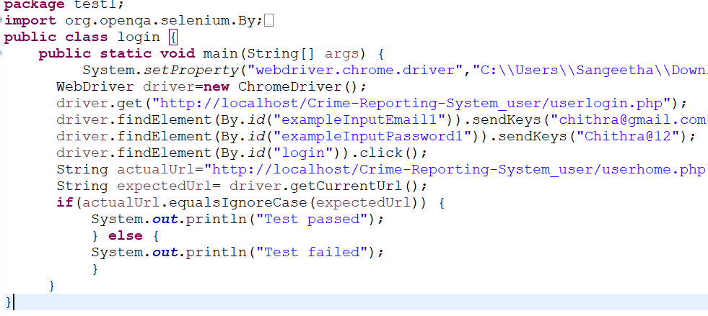

**Eg.Screenshot**

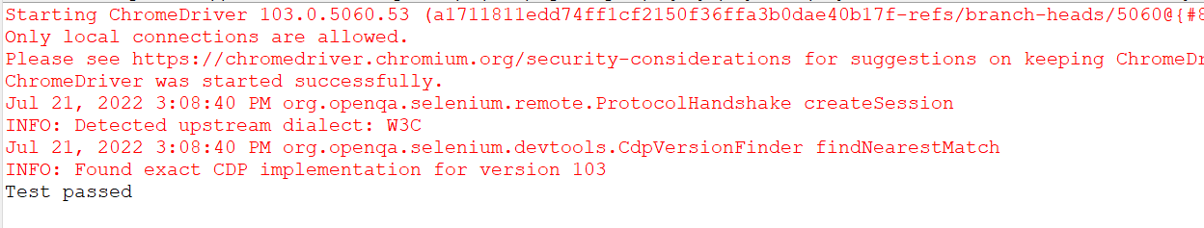

**Eg.Test Report**

|  |  |  |  |  |  |
| --- | --- | --- | --- | --- | --- |
| **Test Case 1** | | | | | |
| **Project Name:** | | | | | |
| **Login Test Case** | | | | | |
| **Test Case ID: Test_1** | | | **Test Designed By:** | | |
| **Test Priority(Low/Medium/High):** | | | **Test Designed Date:** | | |
| **Module Name**: | | | **Test Executed By :** | | |
| **Test Title :** | | | **Test Execution Date:** | | |
| **Description:** | | |  | | |
| **Pre-Condition :**User has valid username and password | | | | | |
| **Step** | **Test Step** | **Test Data** | **Expected Result** | **Actual Result** | **Status(Pass/**  **Fai l)** |
| 1 |  |  |  |  |  |
| 2 |  |  |  |  |  |
| 3 |  |  |
| 4 |  |  |
| 5 |  |  |  |  |  |
|  |  |  |  |  |  |
| 6 |  |  |
| 7 |  |  |  |  |  |
|  |  |  |  |  |
| **Post-Condition:** | | | | | |

**Test Case 2:**

**Code**

**Screenshot**

**Test report**

**Minimum 4 test cases (1 login 3 functionalities)**

# CHAPTER 6

# IMPLEMENTATION

## INTRODUCTION

Explanation

## IMPLEMENTATION PROCEDURES

Explanation

### User Training

Explanation

### Training on the Application Software

Explanation

### System Maintenance

Explanation

# CHAPTER 7

# CONCLUSION AND FUTURE SCOPE

## CONCLUSION

## 

.

* 1. **FUTURE SCOPE**

.

# CHAPTER 8

# BIBLIOGRAPHY

### REFERENCES:

* + - ..
    - ..
    - ..
    - ..
    - ...

### WEBSITES:

* + - [..](http://www.w3schools.com/)
    - [..](http://www.jquery.com/)
    - [..](http://homepages.dcc.ufmg.br/%7Erodolfo/es-1-03/IEEE-Std-830-1998.pdf)
    - [..](http://www.agilemodeling.com/artifacts/useCaseDiagram.html)

# CHAPTER 9

# APPENDIX

## Sample Code

Main functionalities

## Screen Shots